SWE 437-001

Software Testing and Maintenance

Assignment 3: Add Quotations Feature

CLI (Command Line Interface)

*Students:*

Behrad Behmardi

Pisith Yim

*Professor:*

Dr. Jeff Offutt

Git Repository: http://github.com/behmardibehrad/SWE-437-001-Assignment-1.git

**Screen Shots verifying the functionality:**

**Main menu**

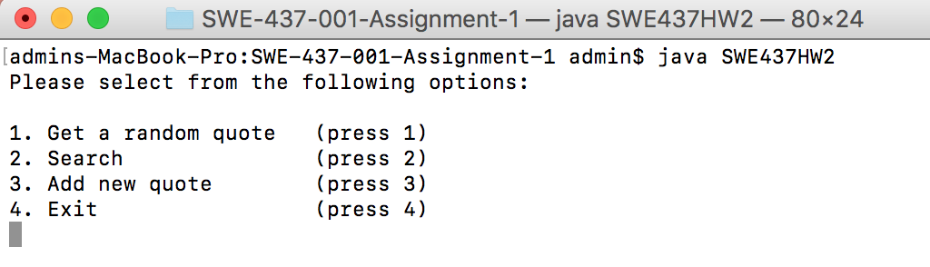

**Add quote (validation and integrity check)**

**Rules: no numbers only, empty string, or database query**

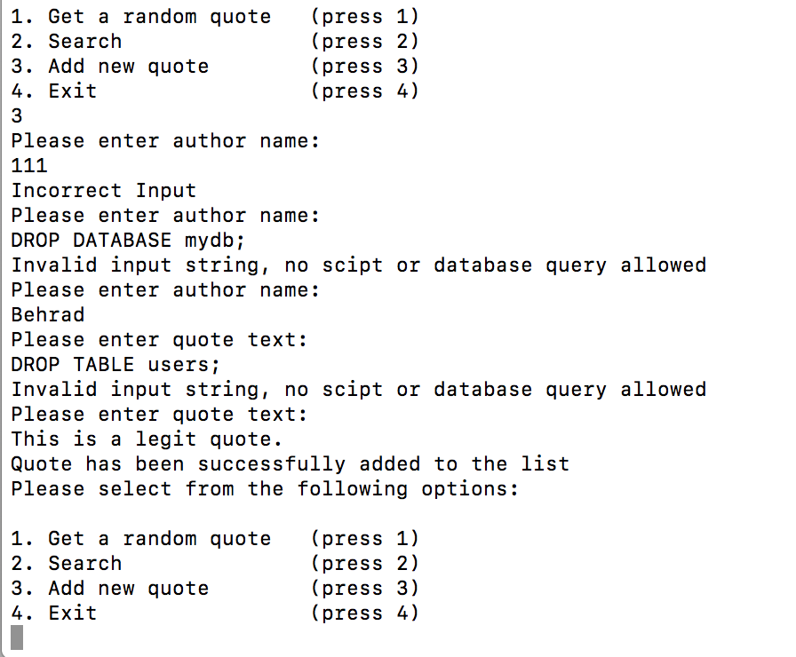

**Retrieve the newly added quote from quotes.xml**

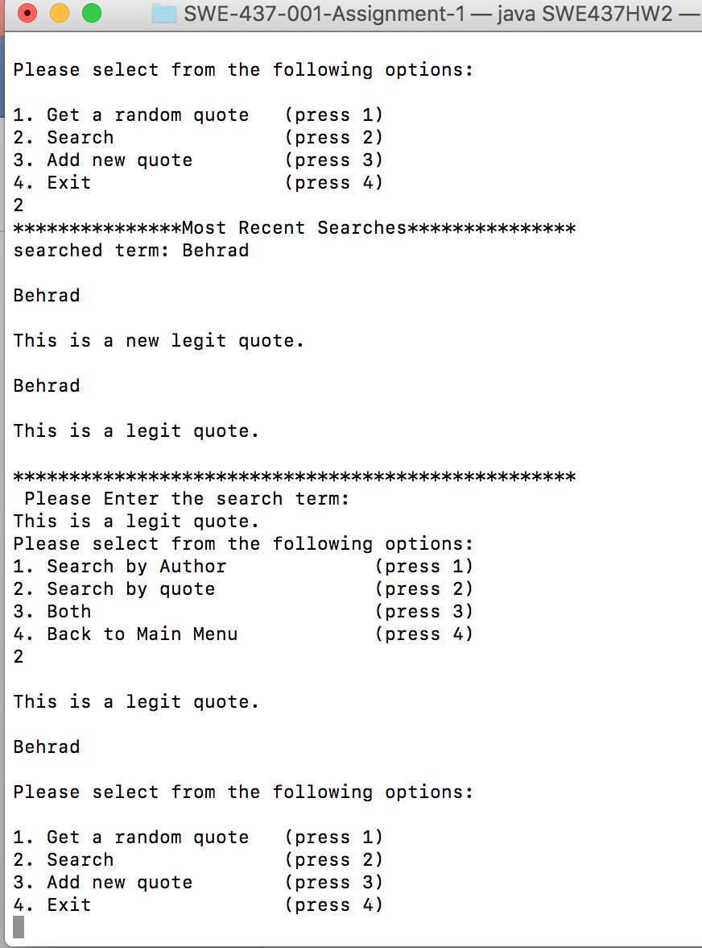

**quotes.xml**

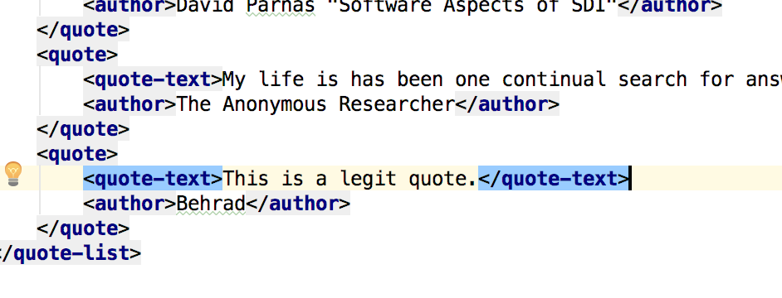

**Documentation Log:**

|  |  |  |
| --- | --- | --- |
| Date | Item | Change |
| 02/10/2018 |  |  |
| 02/11/2018 |  |  |

Implemented Functions in SWE437HW2.java:

GitHub Commit History Table:

|  |  |  |  |
| --- | --- | --- | --- |
| Commit ID | User | Date | Comment |
| 60d0270 | Seth | 02/02/2018 | added pics |
| 266f134 | Behrad Behmardi | 02/02/2018 | editing Readme.md |
| 6b37968 | Seth | 02/02/2018 | editing Readme.md |
| ff76876 | Behrad Behmardi | 02/02/2018 | editing Readme.md |
| 256d49b | Seth | 02/02/2018 | editing Readme.md |
| bce3458 | Behrad Behmardi | 02/02/2018 | Merge branch 'master' of https://SWE-437-001-Assignment-1 |
| 0acb4de | Seth | 02/02/2018 | editing Readme.md |
| 834fd76 | Seth | 02/02/2018 | Add new changes |
| 8cd472d | Seth | 02/02/2018 | Merge changes |
| db1dfee | Seth | 02/02/2018 | New maintainability text |
| 36ad572 | Behrad Behmardi | 02/02/2018 | Update maintainability.md |
| 78c22b1 | Seth | 02/02/2018 | New maintainablility text |
| 4b04ccb | Seth | 02/02/2018 | Add blockquote text |
| ee152d3 | Seth | 02/02/2018 | Changed maintainability.txt to .md |
| 4c2b2de | Seth | 02/02/2018 | Add maintainablilty.txt |
| f3f50b0 | Behrad Behmardi | 02/02/2018 | Delete quoteserve.class |
| bcef17c | Behrad Behmardi | 02/02/2018 | Delete SWE437HW2.class |
| 706c376 | Behrad Behmardi | 02/02/2018 | Delete QuoteSaxParser.class |
| 7469622 | Behrad Behmardi | 02/02/2018 | Delete QuoteSaxHandler.class |
| eab9019 | Behrad Behmardi | 02/02/2018 | Delete Quote.class |
| e17c50b | Behrad Behmardi | 02/02/2018 | Delete QuoteList.class |
| d9d7832 | Behrad Behmardi | 02/02/2018 | organized the documentation |
| adc9e50 | Behrad Behmardi | 02/02/2018 | deleted package name |
| 74d5b92 | Behrad Behmardi | 02/02/2018 | cleaned up and documentation |
| 1b49533 | Behrad Behmardi | 02/02/2018 | fixed comments for PrintSearchMenu() |
| a99205a | Seth | 02/02/2018 | Add switch statement |
| c6f25d3 | Behrad Behmardi | 02/01/2018 | added the scanner and menu options for PrintSearchMenu() |
| df26713 | Seth | 02/01/2018 | Add most recent searches layout |
| 0d16040 | Behrad Behmardi | 02/01/2018 | created function PrintSearchMenu() |
| 31f3d01 | Seth | 02/01/2018 | Create generateRandomQuote method |
| 7839528 | Behrad Behmardi | 02/01/2018 | finished userAnswer(int) function |
| 9d6bebd | Seth | 02/01/2018 | Completed printSearch method |
| b083393 | Behrad Behmardi | 02/01/2018 | created userAnswer(int) function |
| c8903eb | Seth | 02/01/2018 | create printSearch method |
| 7001c69 | Behrad Behmardi | 02/01/2018 | Added comments |
| 3ec44e5 | Seth | 02/01/2018 | Delete e from printMenue method |
| 3d89fb4 | Behrad Behmardi | 02/01/2018 | Added comments |
| 221dd89 | Behrad Behmardi | 02/01/2018 | Create printMenu method |
| 1f30b6e | Behrad Behmardi | 02/01/2018 | Merge branch 'master' of https://github.com/behmardibehrad/SWE-437-001 |
| 9ad9b2d | Behrad Behmardi | 02/01/2018 | Created 'SWE437HW2.java' |

**Maintainability:**

To future proof our code, we would need to make sure that our code is broken down into different reusable components as much as possible. Thanks to the original programmers that made everything easy for us to reuse the existing classes to work with our new written code.

For example, we create a new class call SWE437HW2. This class contains related information, menu, and functions, enough to re-create similar functionality in the web app. We designed this class so that we can make various calls to the existing classes such as QuoteList, Quotes.xml, and Quote, which in turn obtain the same functionality as the web app. Next time, even if we need to write a mobile or desktop GUI app, we should be able to apply this reusable strategy to create the specific code for specific application.

While the original programmers did an amazing job designing the classes for reusability, which made it easy for us to extend it to a command line interface program, there are some refactoring that we could do to improve the program for better maintainability. For example, in quoteserve.java, the original programmers specify a few static variables that happen to be a link URLS to specific pages of the website.

Those links are FileURL, quoteFileName, and this Servlet. The problem is when the URL changes, for example, from cs.gmu.edu to something else, then the links will no longer work. We could easily make changes to the .java file and redeploy the app, but that means that we would have to do this every single time. The preferred way would be dynamically replacing the host name as the application changes and grow. We also need to decompose our methods as much as we can, so that we can reuse them later. For example,

method userSearchAnswer() and printMenu().